Divisibility
# Source: AI Source: Provided by: [Data Path: Persons Table -> ID Column: 1, Name_En Column: Motasem Essam] -> From: [ChatGPT] on [7/13/2026]
Divisibility is a fundamental concept in elementary number theory that describes whether one integer can be divided by another without leaving a remainder. It is the basis for many topics such as factors, multiples, prime numbers, greatest common divisors (GCD), least common multiples (LCM), modular arithmetic, and divisibility tests.

Definition
# Source: AI Source: Provided by: [Data Path: Persons Table -> ID Column: 1, Name_En Column: Motasem Essam] -> From: [ChatGPT] on [7/13/2026]
An integer $a$ is divisible by a nonzero integer $b$ if there exists an integer $k$ such that
$$a=bk$$
This is written as
$$b∣a$$
and is read as
"$b$ divides $a$."
If no such integer exists, then
$$b∤a$$
which is read as
"$b$ does not divide $a$."
where:
- $a$is the dividend
- $b$is the divisor
- $k$is the quotient
- $b≠0$

Divisibility Symbols
# Source: AI Source: Provided by: [Data Path: Persons Table -> ID Column: 1, Name_En Column: Motasem Essam] -> From: [ChatGPT] on [7/13/2026]
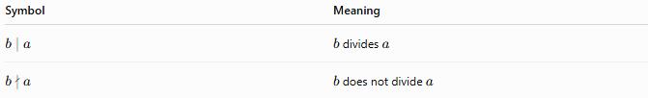
Symbol | Meaning
$$b∣a$$ | $b$divides $a$
$$b∤a$$ | $b$does not divide $a$

Rules of Divisibility

1. Exact Division
# Source: AI Source: Provided by: [Data Path: Persons Table -> ID Column: 1, Name_En Column: Motasem Essam] -> From: [ChatGPT] on [7/13/2026]
If the remainder is zero, the number is divisible.
$$a=bk$$
Example
$$24=6×4$$
Therefore,
$$6∣24$$

2. Non-Exact Division
# Source: AI Source: Provided by: [Data Path: Persons Table -> ID Column: 1, Name_En Column: Motasem Essam] -> From: [ChatGPT] on [7/13/2026]
If the remainder is not zero, the number is not divisible.
Example
$$25÷6=4\text{ remainder }1$$
Therefore,
$$6∤25$$

3. Every Number Divides Itself
# Source: AI Source: Provided by: [Data Path: Persons Table -> ID Column: 1, Name_En Column: Motasem Essam] -> From: [ChatGPT] on [7/13/2026]
For every nonzero integer,
$$a∣a$$
Example
$$15∣15$$

4. One Divides Every Integer
# Source: AI Source: Provided by: [Data Path: Persons Table -> ID Column: 1, Name_En Column: Motasem Essam] -> From: [ChatGPT] on [7/13/2026]
$$1∣a$$
for every integer $a$.
Example
$$1∣250$$

5. Every Integer Divides Zero
# Source: AI Source: Provided by: [Data Path: Persons Table -> ID Column: 1, Name_En Column: Motasem Essam] -> From: [ChatGPT] on [7/13/2026]
For every nonzero integer,
$$a∣0$$
because
$$0=a×0$$
Example
$$7∣0$$

6. Zero Cannot Divide Any Number
# Source: AI Source: Provided by: [Data Path: Persons Table -> ID Column: 1, Name_En Column: Motasem Essam] -> From: [ChatGPT] on [7/13/2026]
Division by zero is undefined.
$$0∤a$$
for every integer $a$.
Example:
$$12÷0$$
Undefined.

7. Sign Does Not Affect Divisibility
# Source: AI Source: Provided by: [Data Path: Persons Table -> ID Column: 1, Name_En Column: Motasem Essam] -> From: [ChatGPT] on [7/13/2026]
If
$$b∣a$$
then
$$\left(-b)∣a,b∣(-a),(-b)∣(-a\right)$$
Example
Since
$$4∣20$$
then
$$-4∣20,4∣-20,-4∣-20$$

Properties of Divisibility
# Source: AI Source: Provided by: [Data Path: Persons Table -> ID Column: 1, Name_En Column: Motasem Essam] -> From: [ChatGPT] on [7/13/2026]
Let $a$, $b$, and $c$ be integers with $b≠0$.

1. Reflexive Property
# Source: AI Source: Provided by: [Data Path: Persons Table -> ID Column: 1, Name_En Column: Motasem Essam] -> From: [ChatGPT] on [7/13/2026]
Every nonzero integer divides itself.
$$a∣a$$

2. Transitive Property
# Source: AI Source: Provided by: [Data Path: Persons Table -> ID Column: 1, Name_En Column: Motasem Essam] -> From: [ChatGPT] on [7/13/2026]
If
$$a∣b$$
and
$$b∣c$$
then
$$a∣c$$
Example
$$2∣8,8∣40$$
Therefore,
$$2∣40$$

3. Addition Property
# Source: AI Source: Provided by: [Data Path: Persons Table -> ID Column: 1, Name_En Column: Motasem Essam] -> From: [ChatGPT] on [7/13/2026]
If
$$d∣a$$
and
$$d∣b$$
then
$$d∣(a+b)$$
Example
$$5∣10,5∣15$$
Therefore,
$$5∣25$$

4. Subtraction Property
# Source: AI Source: Provided by: [Data Path: Persons Table -> ID Column: 1, Name_En Column: Motasem Essam] -> From: [ChatGPT] on [7/13/2026]
If
$$d∣a$$
and
$$d∣b$$
then
$$d∣(a-b)$$
Example
$$6∣30,6∣18$$
Therefore,
$$6∣12$$

5. Multiplication Property
# Source: AI Source: Provided by: [Data Path: Persons Table -> ID Column: 1, Name_En Column: Motasem Essam] -> From: [ChatGPT] on [7/13/2026]
If
$$d∣a$$
then
$$d∣(ac)$$
for every integer $c$.
Example
$$4∣12$$
Therefore,
$$4∣(12×5)=60$$

Examples
# Source: AI Source: Provided by: [Data Path: Persons Table -> ID Column: 1, Name_En Column: Motasem Essam] -> From: [ChatGPT] on [7/13/2026]
Example 1
Determine whether
$$5∣35$$
Since
$$35=5×7$$
the statement is true.

Example 2
Determine whether
$$7∣50$$
Since
$$50=7×7+1$$
the statement is false.

Example 3
Determine whether
$$9∣81$$
Since
$$81=9×9$$
the statement is true.

Example 4
Determine whether
$$11∣121$$
Since
$$121=11×11$$
the statement is true.

Example 5
Determine whether
$$8∣60$$
Since
$$60=8×7+4$$
the statement is false.

Example 6
Determine whether
$$12∣144$$
Since
$$144=12×12$$
the statement is true.

Common Divisibility Table
# Source: AI Source: Provided by: [Data Path: Persons Table -> ID Column: 1, Name_En Column: Motasem Essam] -> From: [ChatGPT] on [7/13/2026]
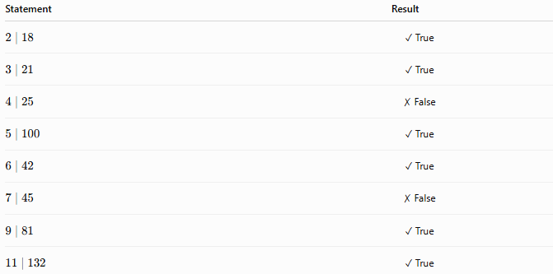
Statement | Result
$$2∣18$$ | ✓ True
$$3∣21$$ | ✓ True
$$4∣25$$ | ✗ False
$$5∣100$$ | ✓ True
$$6∣42$$ | ✓ True
$$7∣45$$ | ✗ False
$$9∣81$$ | ✓ True
$$11∣132$$ | ✓ True

Divisibility Tests
# Source: AI Source: Provided by: [Data Path: Persons Table -> ID Column: 1, Name_En Column: Motasem Essam] -> From: [ChatGPT] on [7/13/2026]
Divisibility rules (also called divisibility tests) are simple procedures used to determine whether an integer is divisible by another integer without performing long division. These rules rely on patterns in the decimal representation of numbers and are widely used in arithmetic and elementary number theory.
Divisibility tests simplify calculations involving factors, multiples, prime numbers, greatest common divisors (GCD), least common multiples (LCM), and prime factorization.

Definition
# Source: AI Source: Provided by: [Data Path: Persons Table -> ID Column: 1, Name_En Column: Motasem Essam] -> From: [ChatGPT] on [7/13/2026]
A divisibility rule is a mathematical test used to determine whether one integer is divisible by another integer without calculating the quotient directly.
If an integer $a$satisfies the rule for a divisor $d$, then
$$d∣a$$
Otherwise,
$$d∤a$$
where:
- $a$is the number being tested
- $d$is the divisor

Common Divisibility Rules

1. Divisibility by 2
# Source: AI Source: Provided by: [Data Path: Persons Table -> ID Column: 1, Name_En Column: Motasem Essam] -> From: [ChatGPT] on [7/13/2026]
A number is divisible by 2 if its last digit is:
$$0, 2, 4, 6, 8$$
Examples
$$248$$
Last digit:
$$8$$
Therefore,
$$2∣248$$

$$735$$
Last digit:
$$5$$
Therefore,
$$2∤735$$

2. Divisibility by 3
# Source: AI Source: Provided by: [Data Path: Persons Table -> ID Column: 1, Name_En Column: Motasem Essam] -> From: [ChatGPT] on [7/13/2026]
A number is divisible by 3 if the sum of its digits is divisible by 3.
Examples
$$372$$
Digit sum:
$$3+7+2=12$$
Since
$$3∣12$$
then
$$3∣372$$

$$524$$
Digit sum:
$$5+2+4=11$$
Since
$$3∤11$$
then
$$3∤524$$

3. Divisibility by 4
# Source: AI Source: Provided by: [Data Path: Persons Table -> ID Column: 1, Name_En Column: Motasem Essam] -> From: [ChatGPT] on [7/13/2026]
A number is divisible by 4 if its last two digits form a number divisible by 4.
Examples
$$916$$
Last two digits:
$$16$$
Since
$$4∣16$$
then
$$4∣916$$

$$918$$
Last two digits:
$$18$$
Since
$$4∤18$$
then
$$4∤918$$

4. Divisibility by 5
# Source: AI Source: Provided by: [Data Path: Persons Table -> ID Column: 1, Name_En Column: Motasem Essam] -> From: [ChatGPT] on [7/13/2026]
A number is divisible by 5 if its last digit is
$$0$$
or
$$5$$
Examples
$$630$$
Therefore,
$$5∣630$$

$$632$$
Therefore,
$$5∤632$$

5. Divisibility by 6
# Source: AI Source: Provided by: [Data Path: Persons Table -> ID Column: 1, Name_En Column: Motasem Essam] -> From: [ChatGPT] on [7/13/2026]
A number is divisible by 6 if it is divisible by both 2 and 3.
Examples
$$324$$
Last digit is even.
Digit sum:
$$3+2+4=9$$
Since
$$2∣324$$
and
$$3∣324$$
then
$$6∣324$$

$$318$$
Last digit is even.
Digit sum:
$$3+1+8=12$$
Therefore,
$$6∣318$$

6. Divisibility by 7
# Source: AI Source: Provided by: [Data Path: Persons Table -> ID Column: 1, Name_En Column: Motasem Essam] -> From: [ChatGPT] on [7/13/2026]
There is no simple digit rule for 7.
One common method:
- Double the last digit.
- Subtract it from the remaining leading number.
- Repeat if necessary.
- If the result is divisible by 7, the original number is divisible by 7.
Example
Test
$$203 \\ 20-(2×3)=14$$
Since
$$7∣14$$
then
$$7∣203$$

7. Divisibility by 8
# Source: AI Source: Provided by: [Data Path: Persons Table -> ID Column: 1, Name_En Column: Motasem Essam] -> From: [ChatGPT] on [7/13/2026]
A number is divisible by 8 if its last three digits form a number divisible by 8.
Examples
$$512$$
Since
$$8∣512$$
then
$$8∣512$$

$$514$$
Since
$$8∤514$$
then
$$8∤514$$

8. Divisibility by 9
# Source: AI Source: Provided by: [Data Path: Persons Table -> ID Column: 1, Name_En Column: Motasem Essam] -> From: [ChatGPT] on [7/13/2026]
A number is divisible by 9 if the sum of its digits is divisible by 9.
Examples
$$729$$
Digit sum:
$$7+2+9=18$$
Since
$$9∣18$$
then
$$9∣729$$

$$731$$
Digit sum:
$$7+3+1=11$$
Therefore,
$$9∤731$$

9. Divisibility by 10
# Source: AI Source: Provided by: [Data Path: Persons Table -> ID Column: 1, Name_En Column: Motasem Essam] -> From: [ChatGPT] on [7/13/2026]
A number is divisible by 10 if its last digit is
$$0$$
Examples
$$650$$
Therefore,
$$10∣650$$

$$652$$
Therefore,
$$10∤652$$

10. Divisibility by 11
# Source: AI Source: Provided by: [Data Path: Persons Table -> ID Column: 1, Name_En Column: Motasem Essam] -> From: [ChatGPT] on [7/13/2026]
A number is divisible by 11 if the difference between the sum of alternating digits is divisible by 11.
Example
Test
$$121$$
Alternating sums:
$$(1+1)-2=0$$
Since
$$11∣0$$
then
$$11∣121$$

11. Divisibility by 12
# Source: AI Source: Provided by: [Data Path: Persons Table -> ID Column: 1, Name_En Column: Motasem Essam] -> From: [ChatGPT] on [7/13/2026]
A number is divisible by 12 if it is divisible by both 3 and 4.
Example
$$864$$
Digit sum:
$$8+6+4=18$$
Last two digits:
$$64$$
Since
$$3∣864$$
and
$$4∣864$$
then
$$12∣864$$

Summary Table
# Source: AI Source: Provided by: [Data Path: Persons Table -> ID Column: 1, Name_En Column: Motasem Essam] -> From: [ChatGPT] on [7/13/2026]
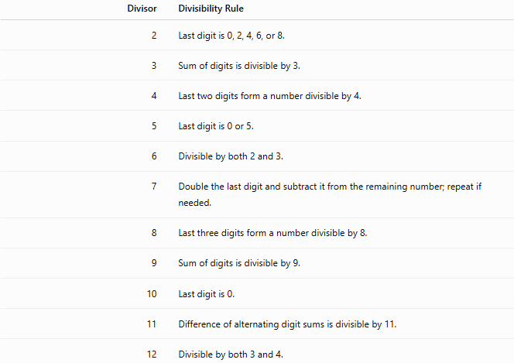
Divisor | Divisibility Rule
2 | Last digit is 0, 2, 4, 6, or 8.
3 | Sum of digits is divisible by 3.
4 | Last two digits form a number divisible by 4.
5 | Last digit is 0 or 5.
6 | Divisible by both 2 and 3.
7 | Double the last digit and subtract it from the remaining number; repeat if needed.
8 | Last three digits form a number divisible by 8.
9 | Sum of digits is divisible by 9.
10 | Last digit is 0.
11 | Difference of alternating digit sums is divisible by 11.
12 | Divisible by both 3 and 4.

Real-Life Applications
# Source: AI Source: Provided by: [Data Path: Persons Table -> ID Column: 1, Name_En Column: Motasem Essam] -> From: [ChatGPT] on [7/13/2026]
Divisibility rules are used in:
- Mental arithmetic
- Number theory
- Mathematics education
- Computer programming
- Cryptography
- Data validation
- Financial calculations
- Inventory management
- Manufacturing
- Scientific computing

Real-Life Examples
# Source: AI Source: Provided by: [Data Path: Persons Table -> ID Column: 1, Name_En Column: Motasem Essam] -> From: [ChatGPT] on [7/13/2026]
1. Classroom Activities
Students use divisibility tests to quickly determine whether numbers can be divided evenly.

2. Packaging
A warehouse checks whether products can be packed equally into boxes without leftovers.

3. Computer Programming
Programs use divisibility tests to identify even numbers, multiples, and perform validations efficiently.

4. Cryptography
Algorithms involving prime numbers often begin with divisibility tests.

5. Manufacturing
Factories determine whether items can be grouped into equal-sized batches.

6. Financial Calculations
Divisibility tests help organize payments or quantities into equal installments.

Common Mistakes
# Source: AI Source: Provided by: [Data Path: Persons Table -> ID Column: 1, Name_En Column: Motasem Essam] -> From: [ChatGPT] on [7/13/2026]
- Confusing divisibility rules for 3 and 9.
- Checking only the last digit for divisibility by 4 or 8.
- Forgetting that divisibility by 6 requires divisibility by both 2 and 3.
- Applying divisibility tests to decimal numbers instead of integers.
- Forgetting that divisibility by 12 requires divisibility by both 3 and 4.

Key Points
# Source: AI Source: Provided by: [Data Path: Persons Table -> ID Column: 1, Name_En Column: Motasem Essam] -> From: [ChatGPT] on [7/13/2026]
- Divisibility rules determine divisibility without long division.
- Most rules depend on the decimal digits of a number.
- They simplify arithmetic and factorization.
- Some divisors (such as 7) require special procedures.
- Divisibility tests are fundamental tools in elementary number theory.

Divisibility vs. Divisibility Rules
# Source: AI Source: Provided by: [Data Path: Persons Table -> ID Column: 1, Name_En Column: Motasem Essam] -> From: [ChatGPT] on [7/13/2026]
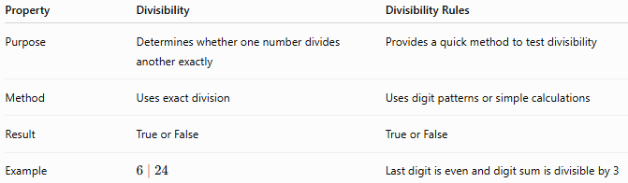
Property | Divisibility | Divisibility Rules
Purpose | Determines whether one number divides another exactly | Provides a quick method to test divisibility
Method | Uses exact division | Uses digit patterns or simple calculations
Result | True or False | True or False
Example | $$6∣24$$ | Last digit is even and digit sum is divisible by 3

Conclusion
# Source: AI Source: Provided by: [Data Path: Persons Table -> ID Column: 1, Name_En Column: Motasem Essam] -> From: [ChatGPT] on [7/13/2026]
Divisibility rules are efficient techniques for determining whether one integer is divisible by another without performing long division. By examining digit patterns or applying simple calculations, these rules make it easy to identify factors and multiples, simplify arithmetic operations, perform prime factorization, and solve problems in elementary number theory. They are widely used in mathematics, computer science, cryptography, and everyday calculations.

Real-Life Applications
# Source: AI Source: Provided by: [Data Path: Persons Table -> ID Column: 1, Name_En Column: Motasem Essam] -> From: [ChatGPT] on [7/13/2026]
Divisibility is used in:
- Arithmetic
- Number theory
- Cryptography
- Computer science
- Coding theory
- Scheduling
- Inventory management
- Manufacturing
- Data organization
- Mathematics education

Real-Life Examples
# Source: AI Source: Provided by: [Data Path: Persons Table -> ID Column: 1, Name_En Column: Motasem Essam] -> From: [ChatGPT] on [7/13/2026]
1. Packaging
A factory has 120 bottles and packs them into boxes of 12 bottles each.
Since
$$12∣120$$
no bottles are left over.

2. Classroom Groups
A teacher divides 30 students into groups of 5.
Since
$$5∣30$$
each group has exactly 5 students.

3. Calendar Planning
A company schedules maintenance every 7 days. Divisibility helps determine when maintenance falls on complete weekly cycles.

4. Manufacturing
A machine produces 500 parts that must be packed into trays of 25.
Since
$$25∣500$$
all trays are filled completely.

5. Computer Programming
Programmers use divisibility to determine whether numbers are even, odd, or multiples of a given value.

6. Cryptography
Many encryption algorithms depend on divisibility and prime factorization.

Common Mistakes
# Source: AI Source: Provided by: [Data Path: Persons Table -> ID Column: 1, Name_En Column: Motasem Essam] -> From: [ChatGPT] on [7/13/2026]
- Confusing division with divisibility.
- Forgetting that the divisor cannot be zero.
- Assuming that every odd number is not divisible by 3.
- Ignoring the remainder when checking divisibility.
- Confusing factors with multiples.

Key Points
# Source: AI Source: Provided by: [Data Path: Persons Table -> ID Column: 1, Name_En Column: Motasem Essam] -> From: [ChatGPT] on [7/13/2026]
- A number is divisible by another if the remainder is zero.
- The divisor must not be zero.
- Every nonzero integer divides itself.
- Every nonzero integer divides zero.
- One divides every integer.
- Divisibility is the foundation of many topics in number theory.

Divisibility vs. Division
# Source: AI Source: Provided by: [Data Path: Persons Table -> ID Column: 1, Name_En Column: Motasem Essam] -> From: [ChatGPT] on [7/13/2026]
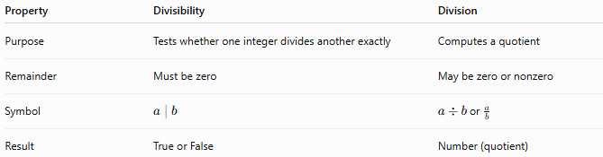
Property | Divisibility | Division
Purpose | Tests whether one integer divides another exactly | Computes a quotient
Remainder | Must be zero | May be zero or nonzero
Symbol | $$a∣b$$ | $a÷b$or $\frac{a}{b}$
Result | True or False | Number (quotient)

Conclusion
# Source: AI Source: Provided by: [Data Path: Persons Table -> ID Column: 1, Name_En Column: Motasem Essam] -> From: [ChatGPT] on [7/13/2026]
Divisibility is the property that determines whether one integer divides another exactly without leaving a remainder. It is expressed using the notation $b∣a$and forms the basis of many important concepts in elementary number theory, including factors, multiples, prime numbers, GCD, LCM, modular arithmetic, and cryptography. Understanding divisibility is essential for solving mathematical problems involving integers and their relationships.

